CX-008 Addresses, Hotels and Maps 10 September 2006

Bank of Spain: 522 Alcalá. 28027 Madrid. Metro Suanzes.
Ignacio Boixo Phone +34 91 3386452 Mobile +34 618526434
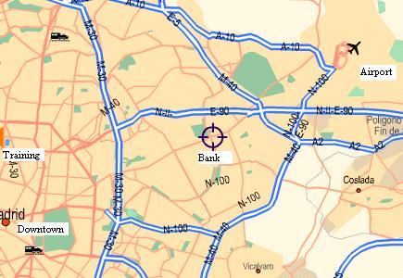
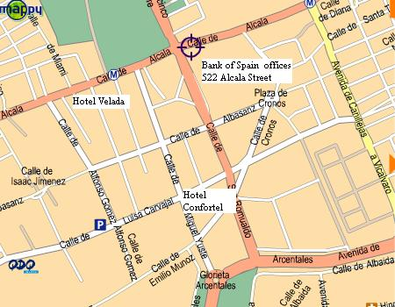
Hotels near Bank of Spain at Alcalá.

Hotel Velada Madrid
C/ Alcalá, 476
Ph: +34 91 375 68 00
Fx: +34 91 375 68 04
reservas.madrid@veladahoteles.com
www.veladahoteles.com
Double (single use): 110 € + 7% VAT
Double: 132 € + 7% VAT
Breakfast included
Please ask for Bank of Spain rate

Hotel Confortel Alcalá Norte
San Romualdo, 30
Ph: +34 91 754 84 00
Fx: +34 91 754 84 08
com.confortel@once.es
www.confortelhoteles.com
Double (single use): 99 € + 7% VAT
Double (suite): 117 € + 7% VAT
Breakfast (no included): 13,50 € + 7% IVA
Please ask for Bank of Spain rate

Downtown Hotels

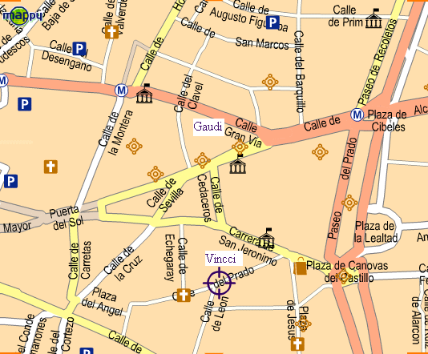
Hotel Gaudí
Gran Via 9, 28013 Madrid
Ph: +34 91 531 22 22
Fx: +34 91 531 54 69
www.hoteles-catalonia.com
gaudi@hoteles-catalonia.es
Double (single use): about 122 € + 7% IVA (breakfast included)
Please ask for Bank of Spain rate

Hotel Vincci Soho
Marqués de Casa Riera, 4. 28014 Madrid
Ph: +34 91 531 69 00
Fx: +34 91 521 71 41
http://www.hotelsuecia.com/
Double (single use): about 114 € + 7% VAT (breakfast included)
Please ask for Bank of Spain rate

Both hotels are at 30 minutes to Bank of Spain offices in Alcalá 522 by Metro (Plaza de la Cibeles station -Banco de España headquarters- to Suanzes station -Banco de España technical building-)

Recommended Travel Agency: Viajes El Corte Inglés congresoxbrl@viajeseci.es

Restaurants and others

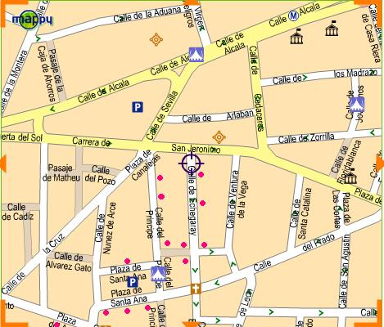
City centre. This area is full of restaurants, bars and others.
This is only an example

“La Trucha” Good fish
“Hylogi” Great variety
“Don ZoKo” Japanese
“Luarqués” Traditional
“Prada a tope” Wonderful tapas
“La Moderna” Nice atmosphere

“Los Gabrieles” Bar. Decoration for remember
“Viva Madrid” Bar. International clients
“Cervecería Alemana” Beer
“La Venencia” Sherry wines
“Café Prado”. Vienna tradition
“Café Central” Live music

And so on….

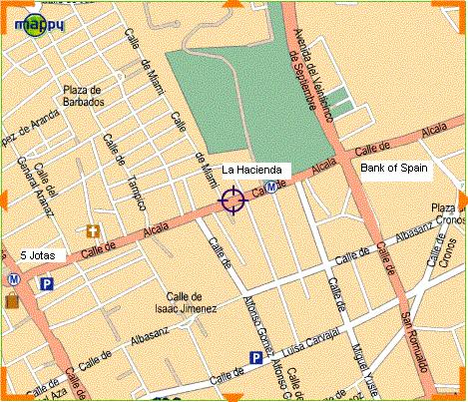
Restaurant
“La Hacienda”
Alcalá, 505
Probably the best option near the Bank of Spain

5 Jotas
A bit more expensive, but outstanding quality

Near 5 Jotas are other restaurants with good quality at a reasonable price.

